Practice Questions

MCQs

If 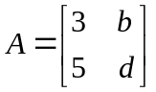 , then which of the following is the determinant of  ?

(a) 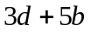
(b) 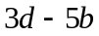
(c) 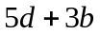
(d) 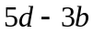

If the matrix 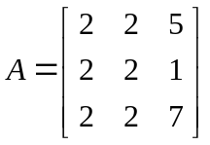 , then which of the following is true about it?

(a) Its determinant is 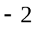 .
(b) Its determinant is .
(c) Its determinant is .
(d) The information is not sufficient to calculate the determinant .

Short

Question No. 1. If the following system of linear equations is solved using the Jacobi’s method, then construct the matrix from the coefficient matrix of the following linear system:

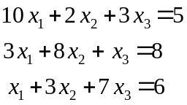
Answer: 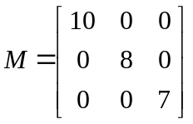

Question No. 2. If the first iteration 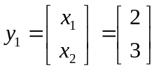 , then use the Jacobi Iteration to find next two iterations of the following system of equations:

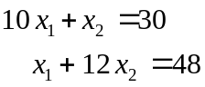

Answer: 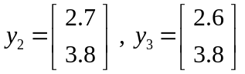
Question No. 3. Evaluate the determinant 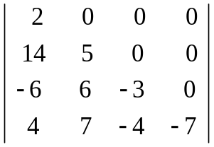 .

Answer: 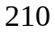

Long
Question No. 4. Verify that 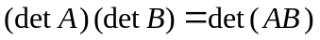, where 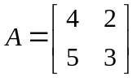 and 

